Kunhui Zhang (001563549)

**Program Structures & Algorithms**

**Fall 2021**

**Assignment No. 2** **(Benchmark)**

* **Task (List down the tasks performed in the Assignment)**

Part1:

1. Implement methods of Timer.java;
2. Run and pass unit tests (BenchmarkTest and TimerTest) after implementing Timer.java

Part2:

1. Implement the method named sort () in InsertionSort.java and achieve Insertion Sort.
2. Run and pass unit tests, InsertionSortTest.

Part3:

1. Implement a main program in InsertionSort to measure the running times of this sort (I finished before), using four different arrays: random, ordered, partially-ordered and reverse-ordered.
2. Draw conclusions from observations regarding the order of growth.

* **Relationship Conclusion: (For ex : z = a * b)**

As the graph showed in evidence, the relationship among times of four different arrays for insertion sort is:

Reverse-ordered > Random > Partially-ordered > Order

(time which is spent on sorting)

* **Evidence to support the conclusion:**

1. **Output (Snapshot of Code output in the terminal)**

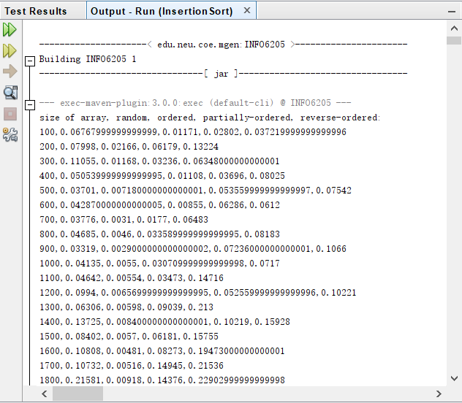

1. **Graphical Representation(Observations from experiments should be tabulated and analyzed by plotting graphs(usually in excel) to arrive on the relationship conclusion)**

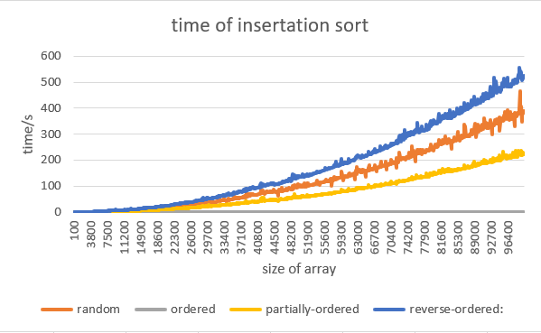

* **Unit tests result:(Snapshot of successful unit test run)**
  1. TimerTest:

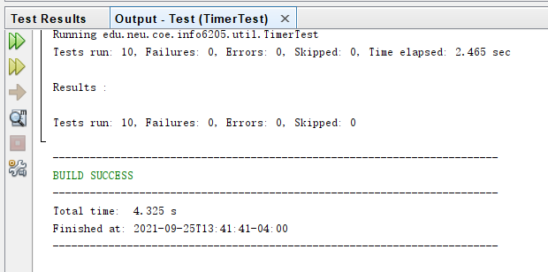

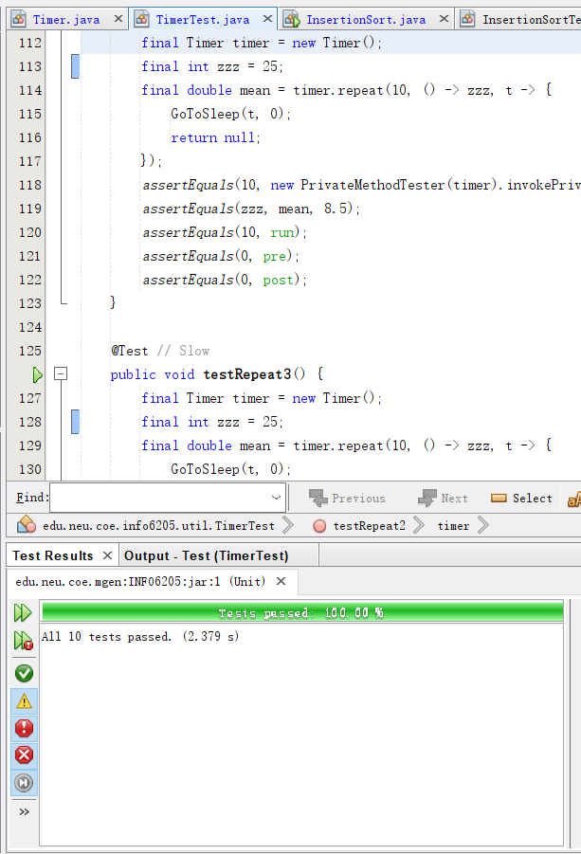

* 1. BenchmarkTest:

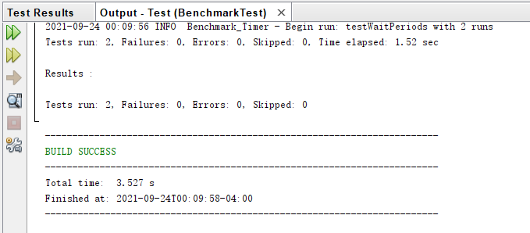

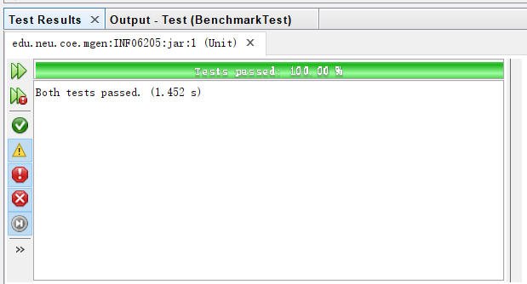

* 1. InsertionSortTest:

